PART-B
PRACTICAL 1:
Aim: Write an HTML/JavaScript page to create login page with validations.
Source Code:
<html>
<head>
<title>Login Page</title>
<style>
body {
font-family: Arial;
background-color: #f2f2f2;
}
.login-box {
width: 300px;
margin: 100px auto;
padding: 20px;
background: white;
border-radius: 10px;
box-shadow: 0px 0px 10px gray;
}
h2 {
text-align: center;
}
input {
width: 100%;
padding: 10px;
margin: 10px 0;
}
button {
width: 100%;
padding: 10px;
background-color: blue;
color: white;
border: none;
cursor: pointer;
}
button:hover {
background-color: darkblue;
}
.error {
color: red;
font-size: 14px;
}
</style>
<script>
function validateForm() {
var username = document.getElementById("username").value;
var password = document.getElementById("password").value;
var errorMsg = document.getElementById("error");

errorMsg.innerHTML = "";
if (username == "" || password == "") {
errorMsg.innerHTML = "All fields are required!";
return false;
}
if (password.length < 6) {
errorMsg.innerHTML = "Password must be at least 6 characters long!";
return false;
}
alert("Login Successful!");
return true;
}
</script>
</head>
<body>
<div class="login-box">
<h2>Login</h2>
<form onsubmit="return validateForm()">
<input type="text" id="username" placeholder="Enter Username">
<input type="password" id="password" placeholder="Enter Password">
<div id="error" class="error"></div>
<button type="submit">Login</button>
</form>
</div>
</body>
</html>
Output:
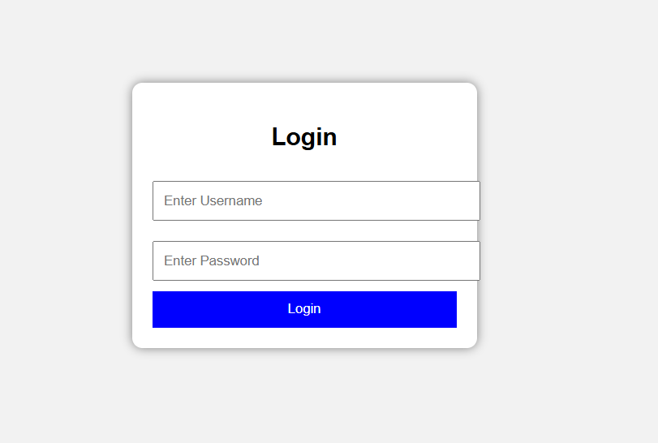

PRACTICAL 2:
Aim: Develop a Simple calculator for addiction, subtraction, multiplication and division operation using JavaScript
Source Code:
<html>
<head>
<title>Calculator</title>
<script>
function calc(op){
let a = +num1.value, b = +num2.value, r;
if(isNaN(a) || isNaN(b)){
result.innerHTML = "Enter numbers!";
return;
}
if(op=='+') r=a+b;
else if(op=='-') r=a-b;
else if(op=='*') r=a*b;
else if(op=='/') r = (b==0) ? "Cannot divide by 0" : a/b;
result.innerHTML = "Result: " + r;
}
</script>
</head>
<body align="center">
<h2>Simple Calculator</h2>
<input id="num1" placeholder="First number"><br><br>
<input id="num2" placeholder="Second number"><br><br>

<button onclick="calc('+')">+</button>
<button onclick="calc('-')">-</button>
<button onclick="calc('*')">*</button>
<button onclick="calc('/')">/</button>
<p id="result"></p>
</body>
</html>
Output:
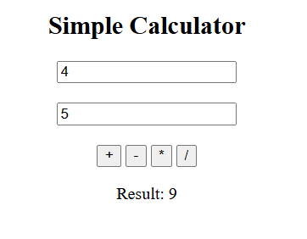

PRACTICAL 3:
Aim: Use Regular Expressions for validations in Login Page using JavaScript
Source Code:
<html>
<head>
<title>Login</title>
<script>
function validate(){
let user = username.value;
let pass = password.value;
let userPattern = /^[A-Za-z0-9]{3,}$/; // min 3 chars, no special chars
let passPattern = /^[A-Za-z0-9@#]{6,}$/; // min 6 chars
if(!userPattern.test(user)){
result.innerHTML = "Invalid Username!";
return false;
}
if(!passPattern.test(pass)){
result.innerHTML = "Invalid Password!";
return false;
}
result.innerHTML = "Login Successful!";
return false;
}
</script>
</head>
<body align="center">
<h2>Login Page</h2>
<form onsubmit="return validate()">
<input id="username" placeholder="Username"><br><br>
<input id="password" type="password" placeholder="Password"><br><br>
<button type="submit">Login</button>
</form>
<p id="result"></p>
</body>
</html>
Output:
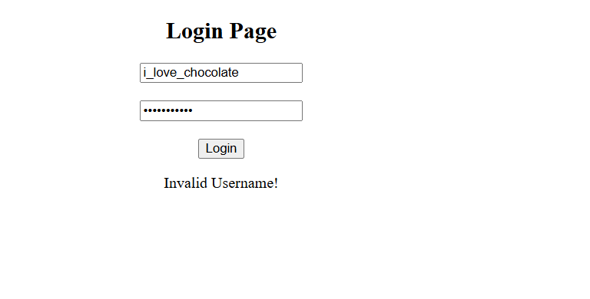

PRACTICAL 4:
Aim: Write a JavaScript program using Switch case.
Source Code:
<html>
<head>
<title>Switch Case Example</title>
</head>
<body>
<h2>Day Finder using Switch Case</h2>
<script>
let day = prompt("Enter a number (1-7):");
switch(day) {
case "1":
document.write("Monday");
break;
case "2":
document.write("Tuesday");
break;
case "3":
document.write("Wednesday");
break;
case "4":
document.write("Thursday");
break;
case "5":
document.write("Friday");
break;
case "6":
document.write("Saturday");
break;
case "7":
document.write("Sunday");
break;
default:
document.write("Invalid Input");
}
</script>
</body>
</html>
Output:
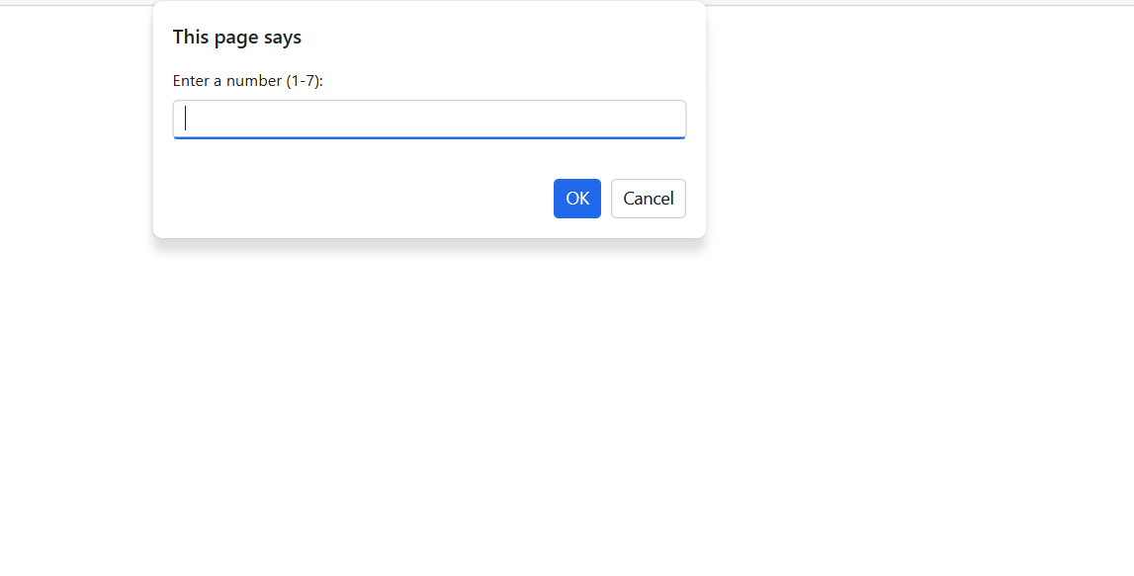
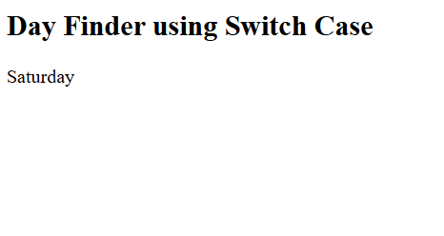

PRACTICAL 5:
Aim: Write a JavaScript program using any 5 events.
Source Code:
<html>
<head>
<title>JavaScript Events Example</title>
<script>
function showMessage() {
alert("Button Clicked!");
}
function changeText() {
document.getElementById("text").innerHTML = "You hovered over me!";
}
function normalText() {
document.getElementById("text").innerHTML = "Hover over this text";
}
function showInput() {
let name = document.getElementById("name").value;
document.getElementById("result").innerHTML = "Hello " + name;
}
function pageLoaded() {
alert("Page Loaded Successfully!");
}
</script>
</head>
<body onload="pageLoaded()">
<h2>JavaScript Events Demo</h2>
<button onclick="showMessage()">Click Me</button>
<br><br>
<p id="text" onmouseover="changeText()" onmouseout="normalText()">
Hover over this text
</p>
Enter your name:
<input type="text" id="name" onchange="showInput()">
<p id="result"></p>
<input type="text" placeholder="Click here" onfocus="this.style.background='yellow'">
<br><br>
<input type="text" placeholder="Click and then leave" onblur="this.style.background='lightgray'">
</body>
</html>

Output:
